

Be A Barrier Buster!
See an Accessibility Barrier? Report It.

Use the City of Kelowna’s accessibility feedback tool to tell them about the barrier and how they can improve.

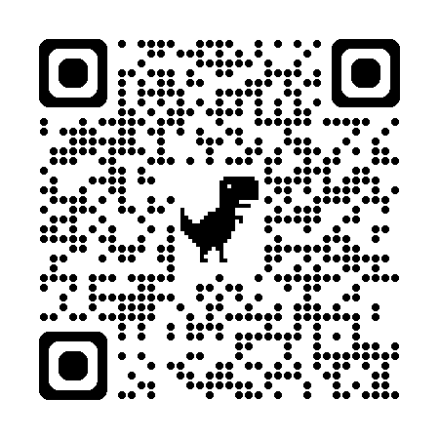
Online: https://www.kelowna.ca/our-community/engage/accessibility
By phone: 250-469-8500
Or in-person at Kelowna city hall
You can report an accessibility barrier anonymously
or by sharing your contact information.

Did you know?
Your feedback helps identify, remove, and prevent barriers so services, spaces, and information are more accessible for everyone in our community.

What kinds of barriers can you report?
- Physical barriers in buildings, entrances, washrooms, or pathways
- Communication barriers in print, digital, phone, or in-person services
- Technology barriers on websites, apps, or online forms
- Service barriers that make it harder for people to get help or information
Learn more about the Accessible BC Act
https://bcaccessibilityhub.ca/resources/abc-act/
Join the BC Accessibility Forum community on Facebook!

